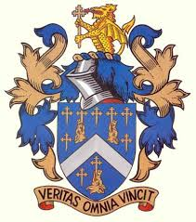
Reading Blue Coat School

BC2 Slough- Windsor Service
Starting 05.09.2023

To Bluecoat:
Slough Yew Tree Road (opp St Mary’s School) 07.05
Datchet Slough Rd (Churchmead school Bus Stop) 07.10
Old Windsor (Clay Hall lane Roundabout Bus Stop) 07.18
Princess Margaret Hospital, Osborne Road 07.20
Windsor (Edward VII Hosp Bus Stop St Leonards Rd) 07.23
Prince Albert PH (Clewer Hill Rd Bus Stop) 07.28
Maypole (Bus Stop Layby Dedworth Road) 07.30
Windsor Road (Fifield Rd Junc Bus Stop) 07.36
Bray/Holyport Turn (Bus Layby A308 Windsor Rd) 07.38
Cox Green (Esso Garage, Shoppenhangers Rd) 07.44
Reading Blue Coat (Approx Arrival Time) 08.25

Coach leaves Bluecoat School at 16.25hrs promptly

All Passes to be shown at All times.

(Timetable revised 5th Sept 2023)

