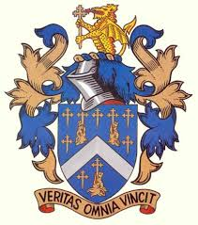
Reading Blue Coat School

BC3 Windsor Ascot Service late Service

Starting 05-09.2022

From Reading Blue coat:

Arrival Home times below for Guidance Only

Blue Coat School: (On School Grounds) 18.00
Binfield Traffic Lights(London rd Layby) 18.12
Harvest Ride (Bus Stop nr Priory lane Junc) 18.19
Jigs Lane Sth (Bus Stop Nr Innings Lane Junc) 18.21
Running Horse Bus Layby (Nr. Bp Garage) 18.23
Martins Heron Roundabout (Bus Stop) 18.24
Ascot High St (Bus st nr “Bar One” M R’about) 18.33
Windsor (Edward VII Hosp St Leonards Rd) 18.45
Prince Albert (Bus Stop on Winkfield Rd nr lights) 18.50

No Fare Required

Do Not Enter The School Before 17.50

