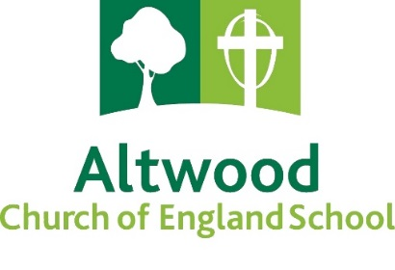

**Altwood Church of England School**

**School Coach Route 2025/2026**

**ROUTE A (72 seats)**

**Stop No.** **Pick Up Drop off**

1. Elliman Avenue (nr. Shackleton Road bus stop) 07:33 16:15
2. Crofthill Road / Farnham Road 07:42 16:08
3. Farnham Royal Pump 07:45 16:05
4. Lynch Hill Lane / Long Furlong Drive (Pub) 07:50 15:57
5. Lower Britwell Road/Ramsey Court 07:55 15:52
6. Hogfair Lane / Reedham Close 07:58 15:47
7. Gore Road / Bredward Close 08:02 15:45

**ROUTE B (72 Seats)**

**Stop No.** **Pick Up Drop off**

1. Lent Rise School 07:45 15:40
2. Dallas Stores 07:47 15:42
3. Bath Road / Huntercombe Lane North (Tax Assist) 07:55 15:45
4. Spring Lane 08:05 15:50
5. Mercian Way / Warner Close 08:08 15:52
6. St Andrews Way / Abbotts Way 08:10 15:56
7. A4 (nr Waldeck Road) 08:20 15:30
8. A4 (layby by Sainsburys, Saint-Cloud Way) 08.22 15:25

**Students will need to be at the pick-up point 10 minutes prior to the collection time stated.**

**Times are approximate and will be dependent on the volume of traffic within the area.**

**Note: Routes and times will be subject to revision depending on demand and the number of children using the coaches.**